Legacy Greens Instagram Growth Hacks and Tips

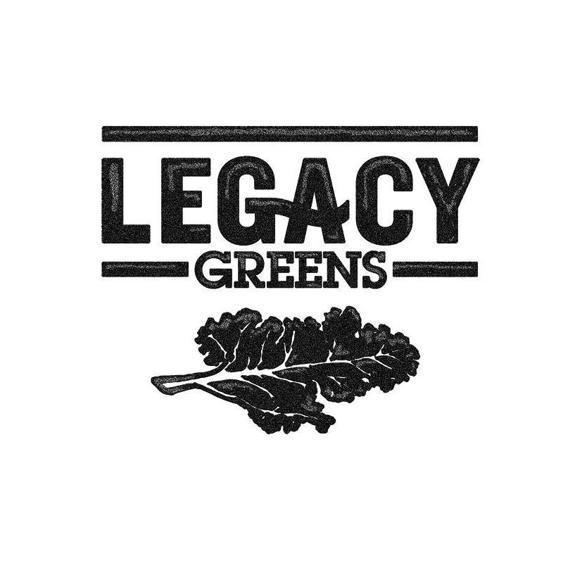

**Audience Overview**

Average Age: 27

Gender: 83% women

Posting habits: at least once a day

Data from Klear.com

**Instagram engagement analysis and VRIN score**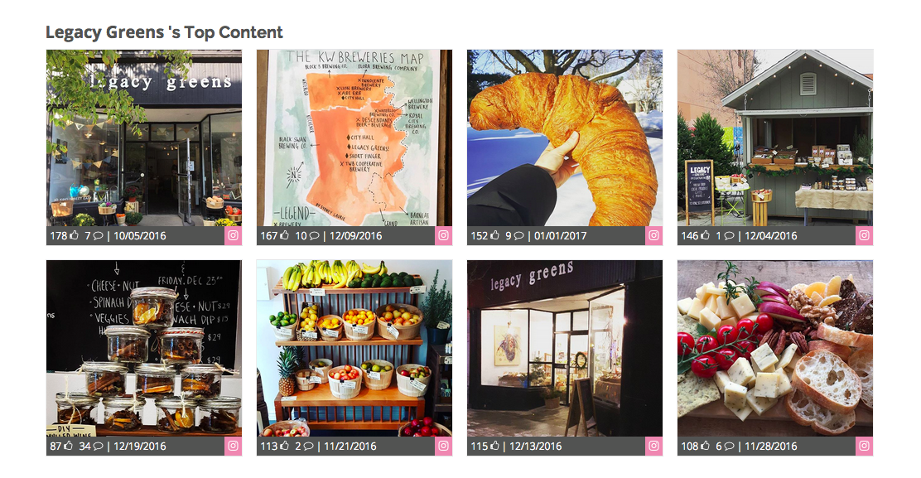

Posts by Legacy Greens that resulted in maximum engagement are:

* Well shot, beautiful angles (picturesque)
* Showcase very rare things (ex: honeycomb in a honey jar, giant croissant)
* Photos of the store from outdoors / outside shot (branding)
* Popular items, for example mulled wine kits, humus (customer cravings)
* Photos that represent the community (social) / pride (solidarity)
* Photos with contents visibly seen, for example, jars of mulled wine kits stacked up (clarity)

Recommendations

* Follow what works to give posts the most engagement possible. Refer to the above list.
* Remind people why you are personally special. Listen to what people say they love about you.
* Try adding mini-stories within some Instagram posts (experiment with this). This is an alternative to having a brand story video.

VRIN score

* Valuable – what is the value? Are people going to be excited to share this?
* Rare – how rare is it?
* Inimitable – how easy can that skill or post be copied and used by a competitor?
* Non-substitutable – how easy is it to substitute?

For example:

Produce box idea was new but it ceased to be rare (R), other businesses copied the same model (I), and there are other convenient ways for customers to buy groceries (N).

**Growing Your Instagram**

Look at local, non-chain businesses. Their followers are more likely within the area. You can interact with their followers.

Proposed accounts:

* @Dtkitchener – 5.5k followers
* @themuseumkitchener – 2.9k followers
* @goodvibesjuicecompany (smoothie & juice bar) – 2.8k followers

Recommended Tools:

* Iconosquare.com – to monitor engagement and growth. It comes with a free trial. Usually costs $9/mo (11.72CAD)
* Socialrank.com – to analyze followers. It’s free. Option to upgrade for $49/mo (63.8CAD)